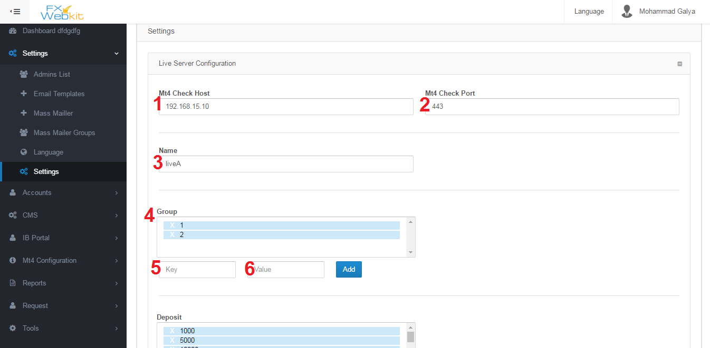

Public settings for the software and server settings you can edit them here :

1. MT Check Host : meta trader server IP .
2. MT4 Check Port : meta trader server port to connect with server throw it.
3. Name: Name of server where every Mt4 users will be distinct according to the server if it's Live server ,demo or you can name the server.
4. Group: Mt4 Users in the server belong to groups so if admin or client wants to add new Mt4 user he has select the group.
5. Key : when software display the list of groups it will display the value and the key for the server so you are free to change value but the key should be come from the server and you cannot change it.
6. Value : descript the group or alias for the group and you can change it as you want.

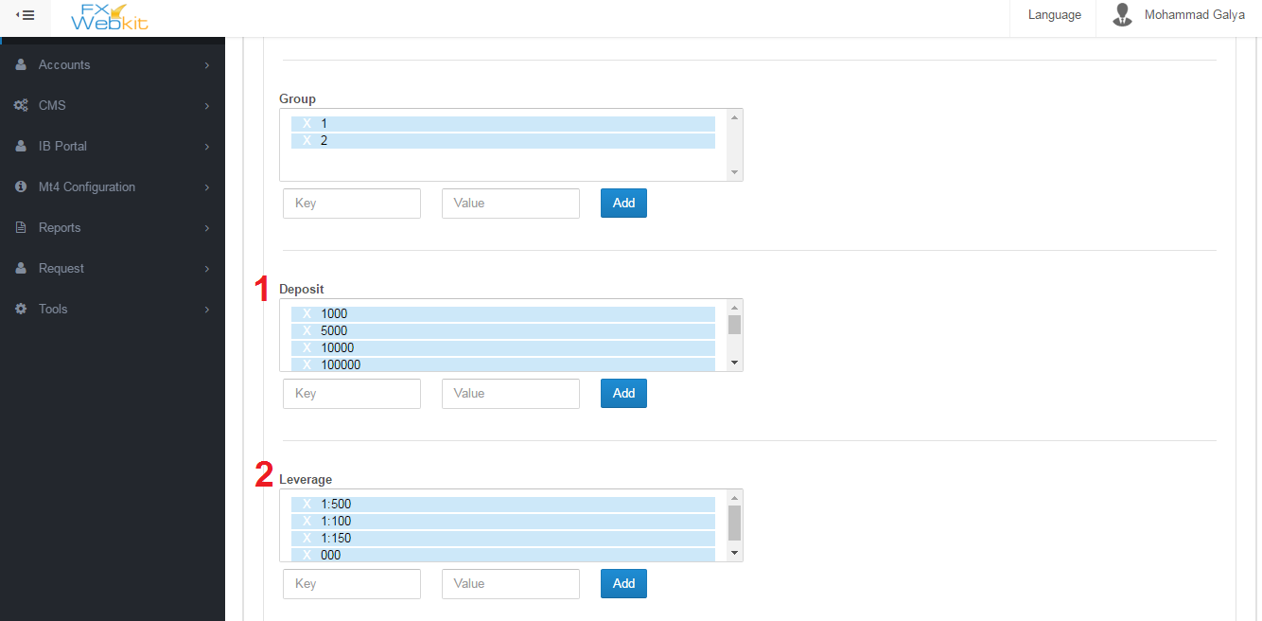

1. Deposit : List the deposit numbers which available on the server and you can delete any one and add also but be careful with key you have to ask server software developer to know what keys available and you are free with value.
2. Leverage : lest of leverage on the live server .

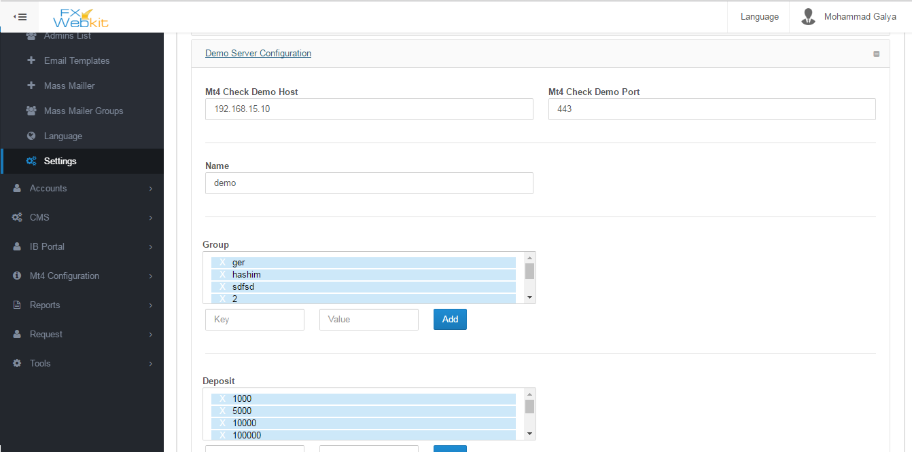

As we see in live server here we have the same settings for demo server and you can set different settings.

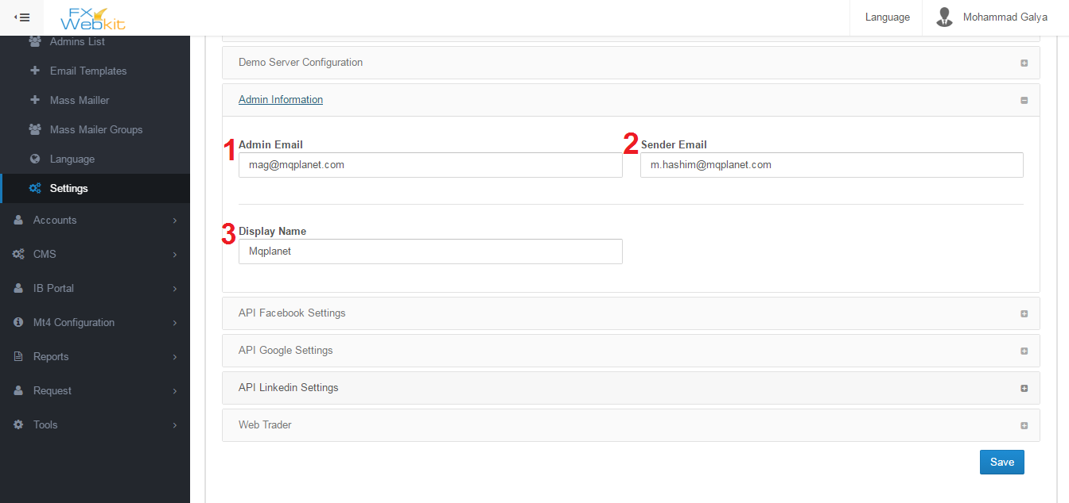

Each Admin has his own info you can see it from users list (admins list ) but this info will be the same for all admins in general you can descript them as email sender settings.

1. Admin Email : for each notification from the software it will sent to this email and all mass mails will be sent to this email.
2. Sender Email : this the email which will all emails out from .
3. Display Name : name of the sender in emails.

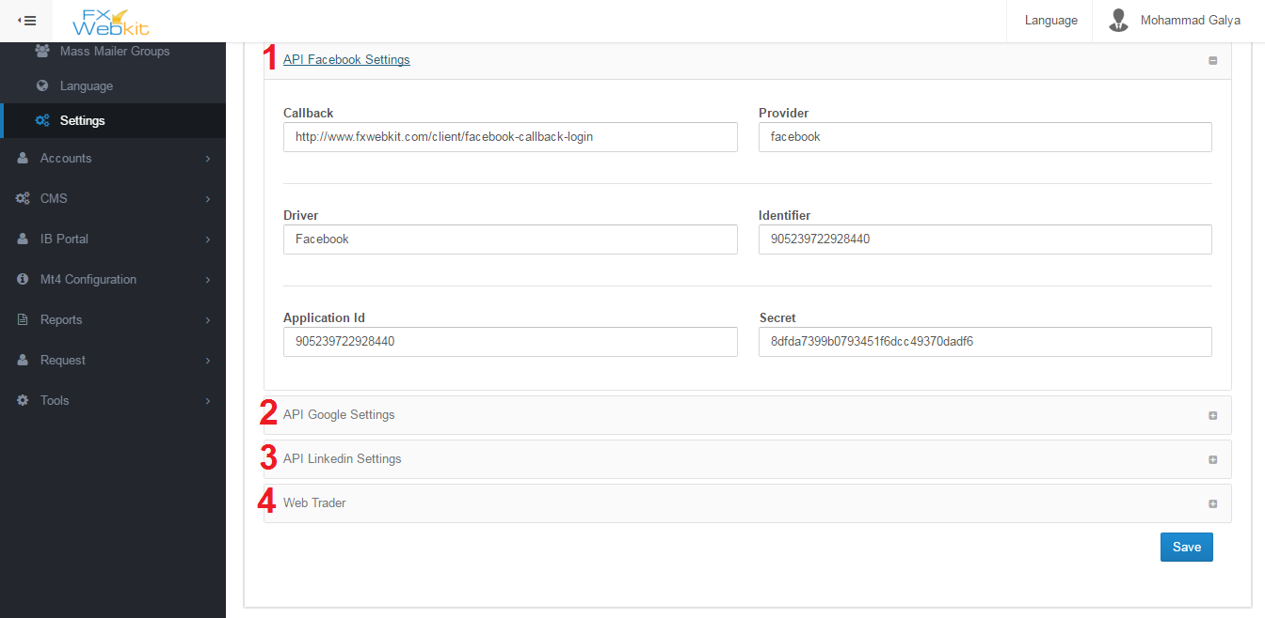

Fxwebkit client area can be entered by registration or login throw social media and to do this operation you have to make applications on the social networks like facebook , google+ and linkedin:

1. API Facebook : you can create your own API . please see <https://developers.facebook.com/> to more information about facebook login API.
2. API Google : you can create your own API . please see https://developers.google.com/ to more information about Google login API.
3. API Linkedin : you can create your own API . please see https://developer.linkedin.com/to more information about Linkedin login API.
4. Web trade : the link for online web trade can be inserted here this link can be display or hidden from client.when you make it available to client by check the check box in this tab there will be new window in client area to trade online.

**Accounts**

Accounts List:

The accounts list is the list for clients who can enter client area of this software . we have seen Accounts list of admins the same thing for clients' accounts but with more actions on them:

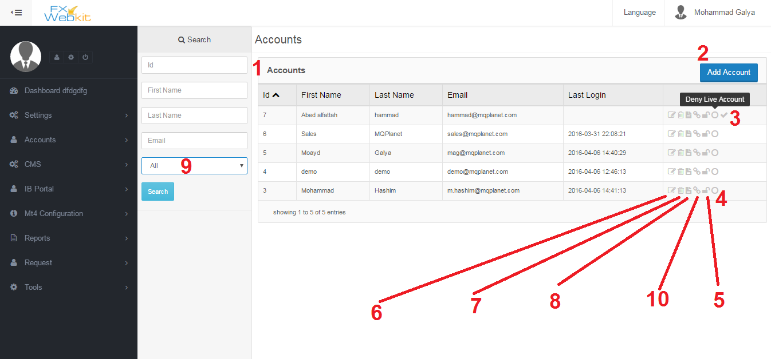

At the first time you enter this window you have to click search button to see the list i.e. the list will be empty until you click search button and the window contain:

1. Clients accounts list : all users who can enter clients area will be listed here .
2. Add Account : this button to add new client press the button fill the details and click save and the new user will be listed here.
3. Active account : when new client register in the client area for the first time his account will be not active until (according to software configurations) he go to his email and click activations button (note :you can edit sent email template using settings ->email templates) ,but when you click this activations icon the client account will be active without go to his email ,then he can enter his account.
4. Deny Create live account: the clients can add Mt4 Users to Live server as we'll see this button can deny some client from create live MT accounts on Live server or allow him.
5. Block Client : toggle this button to block or unblock client when client is blocked he will not be able to log in client area.
6. Edit Client information: like admins list this icon to edit client info email, password …etc.
7. Delete Client: when click this icon the client will not be longer exist .
8. Client Details: client info and personal details .
9. Filter users: If you want filter users and see the active accounts and non-active accounts .
10. Assign MT users to client : every client have number of MT users on live server and demo server , to determine each client MT users use this button to get into assign MT users to client window .see below window:

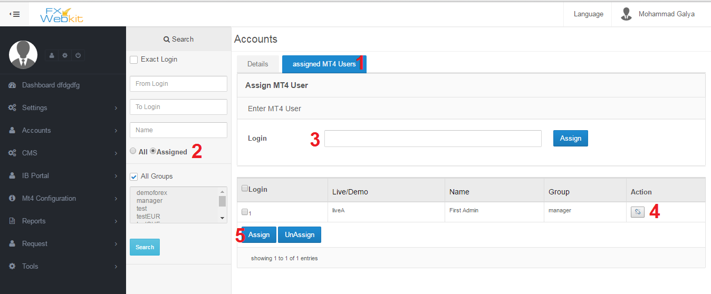

To specific each client MT users so when the client enter clients area he can manage his own MT users and see their details:

1. MT Users list : if you click this tab you see MT users to the client which we click on in users list to see this user details use Details tab .
2. Display All MT users or just this user MT users : filtration the listed users if you want to see all MT users check All and click search then assign new MT users to this user . Check assigned then search to list this user (client ) MT users.
3. Fast assign Login(MT user) : just type MT users login and click assign to add this MT user to this client.

Note : the login will be assigned as alive MT user, to assign demo MT user check All in filter panel and search find your login and click assign button at the end of the row.

1. Toggle Assign & unAssign button: click this button to assign MT user to this user and click it again to un assign the MT user.
2. Multi assign and un assign button: display all MT users using filtration then check the MT users after that you can assign them or un assign them once.

MT Accounts:

In the system we have two server live and demo with MT users on them this window to manage those MT accounts :

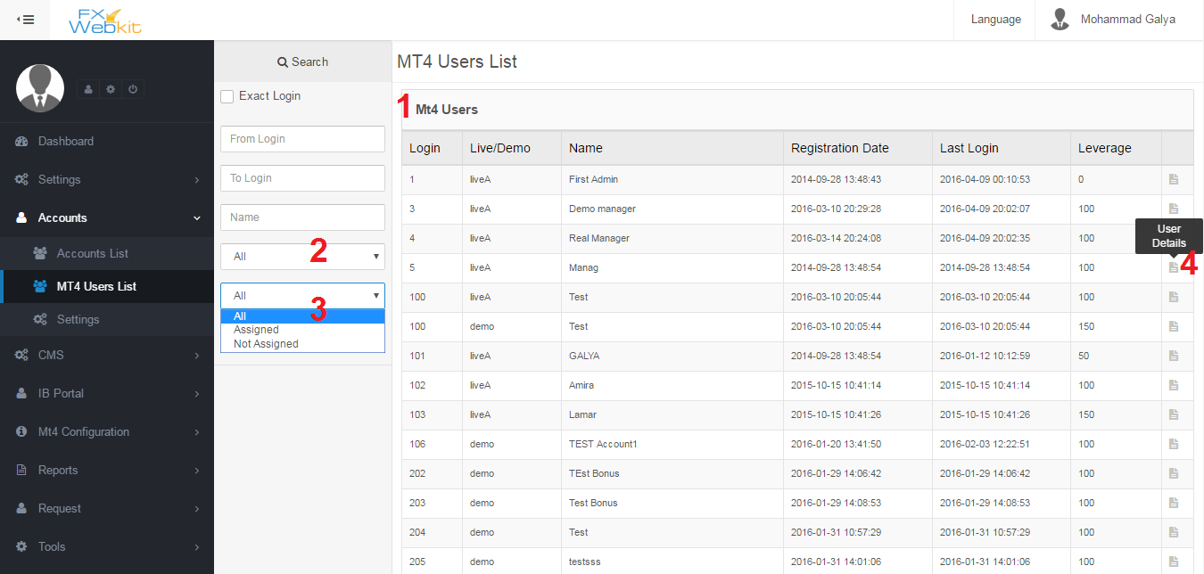

All MT users live and demo are listed here :

1. MT users list: list of users in live and demo servers.
2. Filter users live or demo : you can filter users and distinct the live or demo users just select which users you want listed and click search button.
3. Filter Users (assigned and Not assigned): as we see for each system client in past Accounts list has MT users assigned to him this filter will display list of assigned MT users which assigned to one of fxwebkit clients or unassigned MT users.
4. MT user details: To manage this MT user click on user details icon to see this user summary change leverage, password, internal transfer and withdrawal ,also you can see for any Client( Fxwebkit user) this MT user assign to. See:

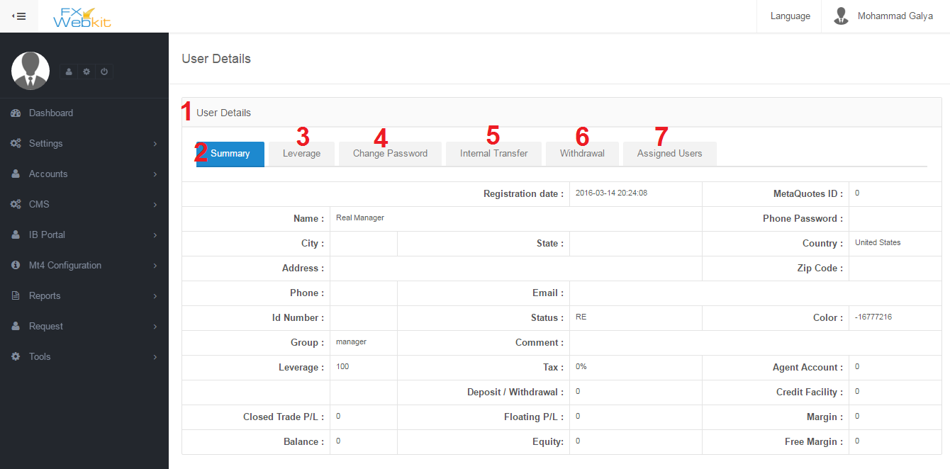

MT user details for live or demo users and change this details :

1. MT users details : all MT user details with tabs to change some sittings of this MT user throw sending request to the server to change those settings.
2. Summary : display info of MT user.
3. Leverage : this tab to change MT users leverage you will find list of available leverages on server which we talk about early in the public settings tab .
4. Change password: MT user password change which he use to login to the trading platforms .
5. Internal transfer : transfer money from this MT user to another user ,just insert MT login and amount and send button .

Note : the admin can control the send to accounts so he can allow if this user can send to any MT user or just to his MT users , we will see this option in the next settings window.

1. Withdrawal: just type the amount and click send .
2. Assigned Users: Client users(Fxwebkit users) has their MT users so to see which user this MT user belong to click this tab to list users that this MT user belong to and remove this relation(un assign ) any one of them.

**Settings :**

This setting just for accounts module to configuration Accounts module and MT users operations :

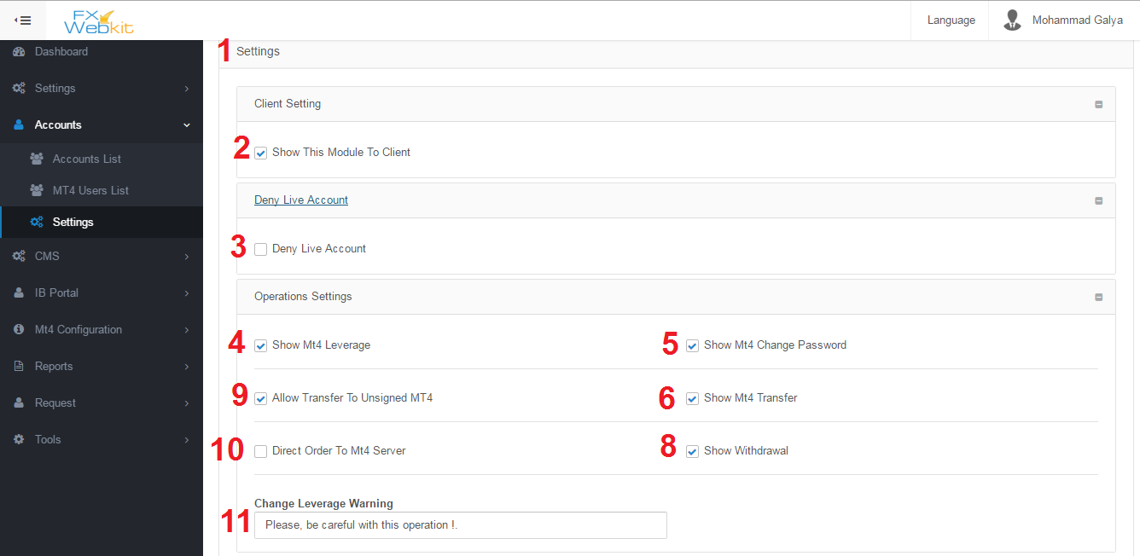

Settings to control accounts and Mt4 operations:

1. Settings Tab: contain multi tabs to categorize setting according to their uses.
2. Show this module to client: in the client area there is accounts menu and to hide it from client area just remove check from this checkbox.
3. Deny Live Account : when new client register in the Fxwebkit software if this option checked the client cannot create live MT user until the admin allow him by check the icon on accounts list on users list(see number 5 in accounts list ).

But if this option not checked and new user(client) register in Fxwebkit then the admin checked this option the user can create live MT account until admin deny him from creating MT live account.

1. Show Mt4 Leverage: in MT user details window there is Change leverage tab this tab can be hidden to client if this option not checked.
2. Show Mt4 Change Password: in MT user details window there is Change Password tab this tab can be hidden to client if this option not checked.
3. Show Mt4 Internal Transfer: in MT user details window there is Internal Transfer tab this tab can be hidden to client if this option not checked.
4. Show Mt4 Withdrawal: in MT user details window there is Withdrawal tab this tab can be hidden to client if this option not checked.
5. Allow Transfer To unassigned MT users : The client (Fxwebkit user) has his own MT users if he want to transfer money between them he can use internal transfer in MT users details. But if he want to transfer money to other MT users(who are not assigned to him ) he cannot if this option not checked.
6. Direct Order To MT server : we have some orders like change password, change leverage , add new MT user , withdrawal and internal transfer those order sent to MT server and apply them there if you want filter these orders and send them first to admin (requests Module) then the admin choose to forward order to the MT server or control them before send them to the server just remove checkbox check to filter orders and deny direct order to MT server.
7. Change leverage warning: this message will be display to client in change leverage tabe.

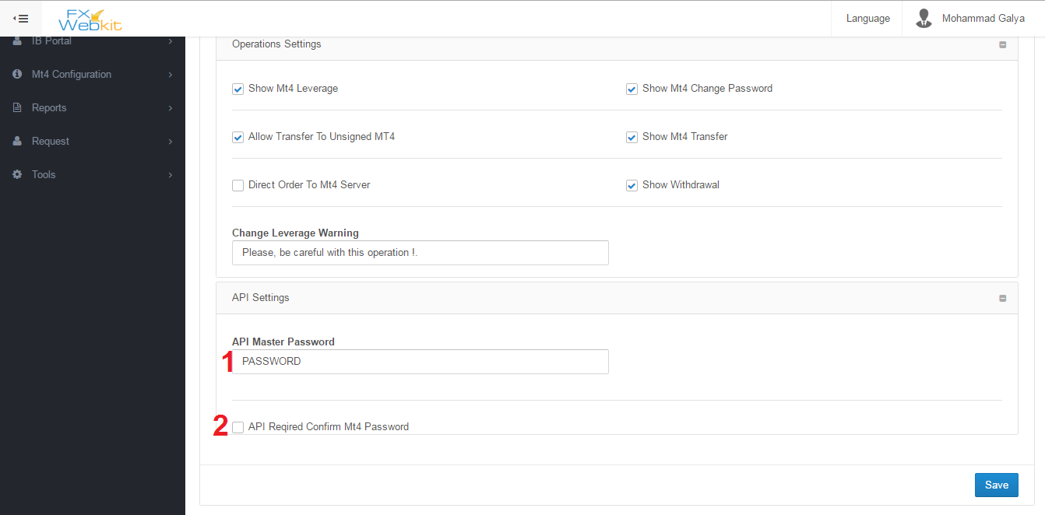

This settings for API developer :

1. API Master Password : this password will be sent with request for MT server.
2. API Required Confirm MT password: If the API developer need MT user password to confirm order ,the client need to insert the MT password with each order like change leverage.